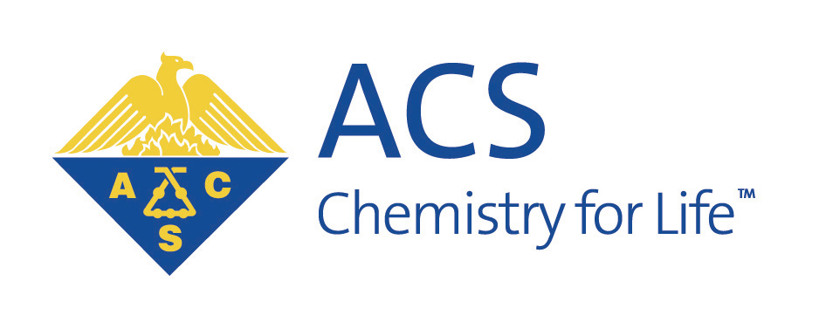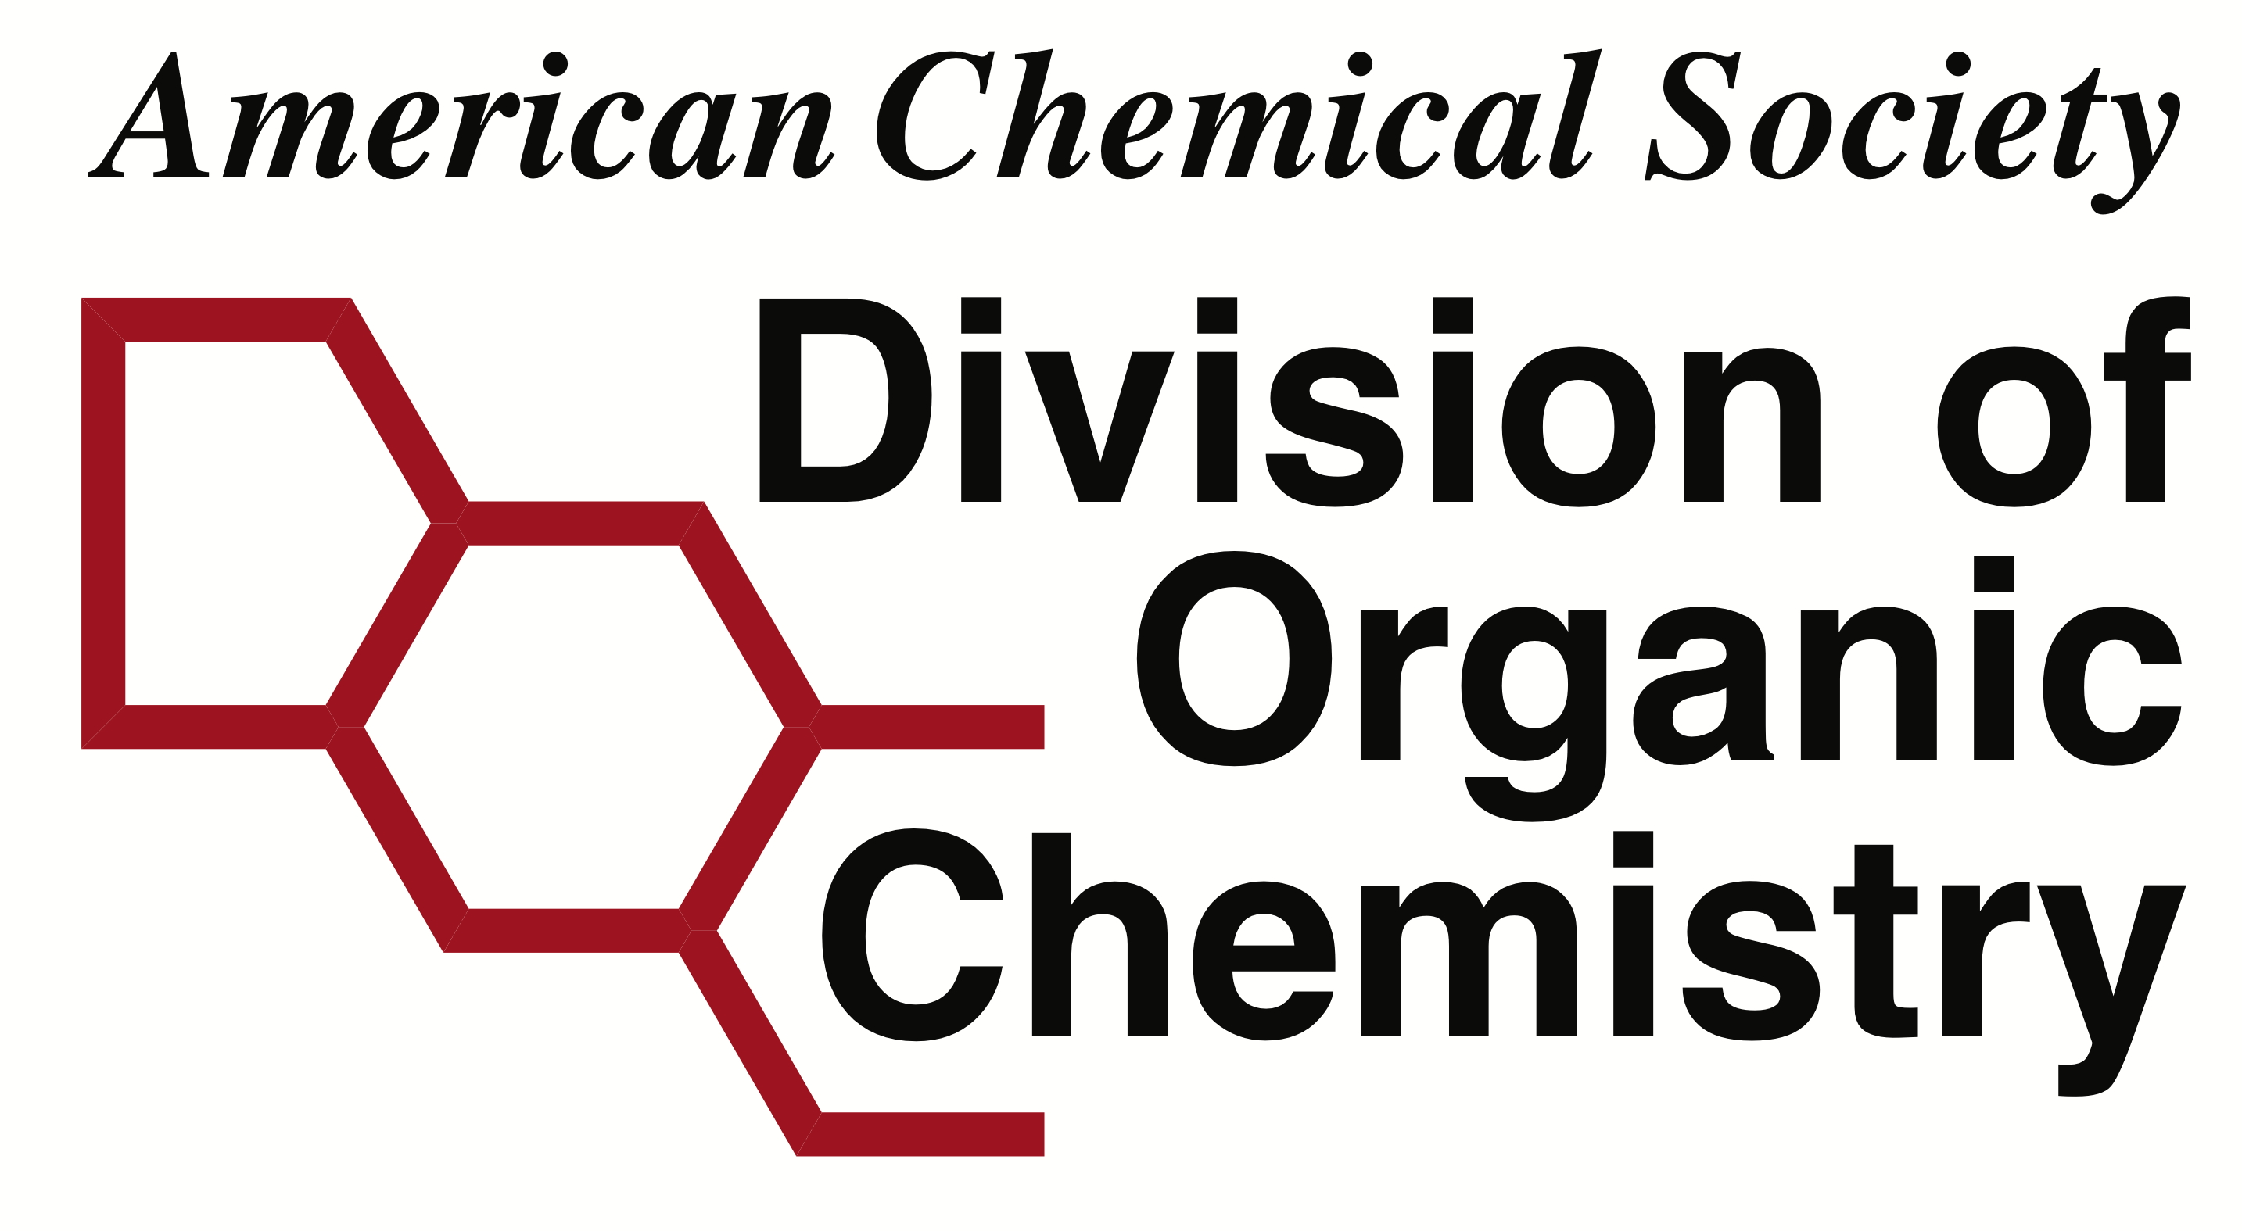
American Chemical Society
Division of Organic Chemistry
Reimbursement Form

International Wire Transfer Information
If you have questions completing this form please contact Treasurer@organicdivision.org.

Name of the person completing this form:
Name of Bank:
Name on the Account:

Address that is on file with the bank (Not the address of the bank, this is a security check!):
Street Address (line 1):
Address (line 2):
(city, state/province, postal code):

Bank Account Information (DOUBLE CHECK THE NUMBERS!)
Currency of the Account:*
IBAN:
SWIFT/BIC:
Account Number:
Other (i.e. IFSC in India)

Wire Transfers will be made in the Foreign Currency of the account (if provided) at the exchange rate managed by the Bank of America at the time of transfer. The Treasurer will email you the confirmation information with the amount you should anticipate. If the currency is not listed (or USD is requested) funds will be transferred in US Dollars and a USD$45 bank charge will be incurred by the Division and amount deducted from the reimbursement.

