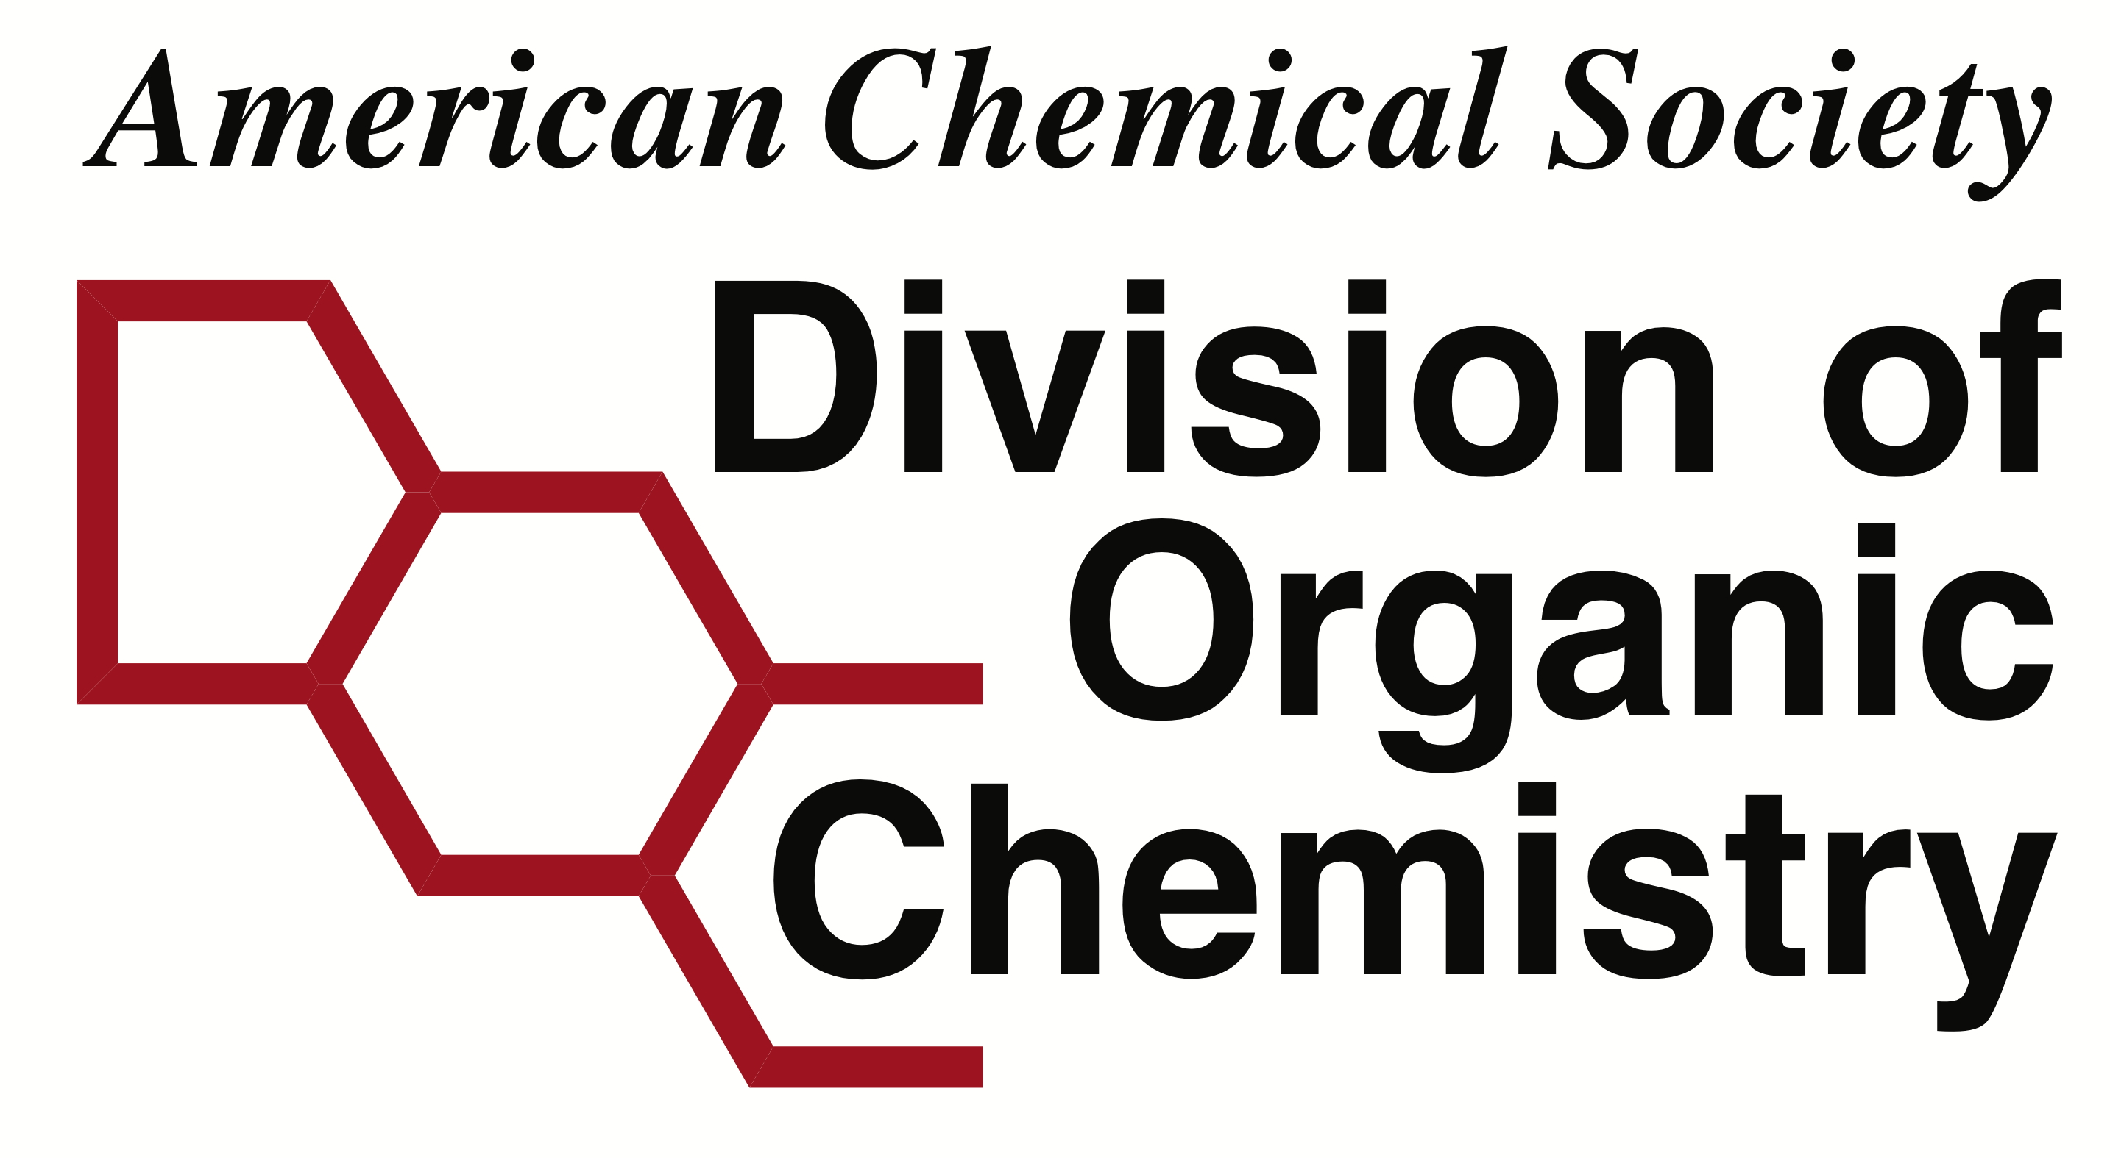
American Chemical Society
Division of Organic Chemistry
Reimbursement Form

General Information

Name of the person completing this form:
Make check payable to:
Affiliation:
Address where check will be sent (home address strongly preferred, no more than 3 lines):
Street Address (line 1):
Address (line 2):
(city, state zip):
E-mail:
Contact Phone Number:
Session Participated in:
(or Reason for Reimbursement)

For speakers outside of US/Canada all reimbursements should be made via wire transfer. Please complete the wire transfer information form (found here) and include in the PDF packet.

Expense Breakdown** | Amount | Details (If Needed)
Airfare/Mileage (non-refundable Coach Only)
Meeting Registration*
Hotel
Ground Transportation
Other: please specify below
Total of Receipts above
Total Requested/approved for Reimbursement

*Reimbursements will only be made up to the early registration amounts if applicable.
**Please see Guidelines for Travel Reimbursement for clarification.
**Attach all relevant receipts and submit as a single PDF file named: lastname_firstname_$$amount.pdf

